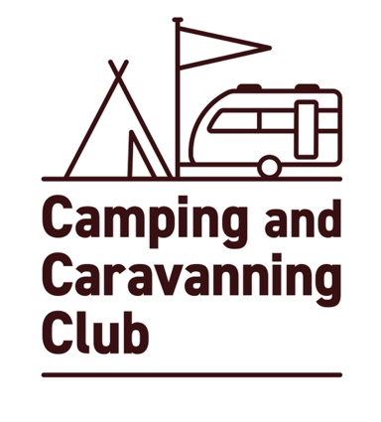
Certificated Site

Attendance Summary Sheet

Please return by 31st December 2024 to:

Exempted Camping Department
The Camping and Caravanning Club
Greenfields House,
Westwood Way,
Coventry,
CV4 8JH

Tel / 024 7647 5198

Owned/Operated by Certificated Site No.

/

Site Address

Please complete this section using the information you have gathered on the CS Attendance Form.

Date of First Arrival Date of Last Arrival

Total No. of:

Caravans Motor Caravans Tents Trailer Tents Total No. of Units

=

Total No. of:

Adults Children Total no. of unit nights camped

Signature of Site Owner Date

