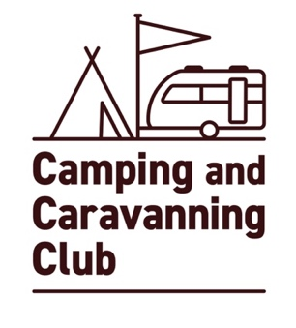
The Camping and Caravanning Club
Adult model release form

To be completed in FULL by photographer / videographer

Photography Videography

Photographer’s name:________________________________________________________________________________________

Shoot Location:_____________________________________________________________ Shoot Date:____________________

Shoot & model description:__________________________________________________________________________________

____________________________________________________________________________________________________________________

____________________________________________________________________________________________________________________

Model’s permission and rights granted:
I hereby give the Photographer/ Videographer my permission to license the images and/or Video Footage and to use these in any Media for any purpose which may include, among others, advertising, promotion, marketing and packaging for any product or service. I agree that the images and/or Video Footage may be combined with other images, text and graphics, and cropped, altered or modified.
I agree that I have no rights to the images and /or Video Footage, and all rights to these belong to the Camping and Caravanning Club. I waiver all rights to claim any money for use of the images / Video Footage.

Model’s signature:______________________________________________________________ Date:_______________________

Model’s printed name:________________________________________________________________________________________

Data protection
The protection of personal privacy is an important concern to the Camping and Caravanning Club. Any personal data collected will be treated in accordance with current data protection legislation.
We will use your personal data in the capture, production and publishing of images, video footage and to administer your model release permission. In doing so, we may share your personal data with photographers, videographers, agencies and content publishers.
For more information about our data protection policy please go to www.campingandcaravanningclub.co.uk/aboutus/privacy-policy/

Name:_________________________________________________________________________________________________ __________
Model’s name maybe used within a caption that accompanies an image

Full Address including postcode:___________________________________________________________________________ ___

Contact number:_______________________________________________________________________________________________ ____
Email Address:_________________________________________________________________________________________________
Updated April 2024

