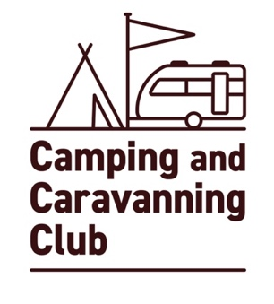
The Camping and Caravanning Club
Minor model release form
(a ‘minor’ is someone under the age of 18)

To be completed in FULL by photographer / videographer

Photography Videography

Photographer’s name:________________________________________________________________________________________

Shoot Location:_____________________________________________________________ Shoot Date:____________________

Shoot & model description:__________________________________________________________________________________

____________________________________________________________________________________________________________________

____________________________________________________________________________________________________________________

Parent/legal guardian’s permission and rights granted:
I hereby give the Photographer/ Videographer my permission to license the images and/or Video Footage and to use these in any Media for any purpose which may include, among others, advertising, promotion, marketing and packaging for any product or service. I agree that the images and/or Video Footage may be combined with other images, text and graphics, and cropped, altered or modified.

I agree that I have no rights to the images and /or Video Footage, and all rights to these belong to the Camping and Caravanning Club. We waiver all rights to claim any money for use of the images / Video Footage.

I confirm that I am legally responsible for the Model.
Parent/legal guardian signature:___________________________________________________ Date:_______________________

Model’s printed name: :___________________________________________________ Model’s DOB:_______________________
Model’s name maybe used within a caption that accompanies an image

Data protection
The protection of personal privacy is an important concern to the Camping and Caravanning Club. Any personal data collected will be treated in accordance with current data protection legislation.

We will use your personal data in the capture, production and publishing of images, video footage and to administer your model release permission. In doing so, we may share your personal data with photographers, videographers, agencies and content publishers.
For more information about our data protection policy please go www.campingandcaravanningclub.co.uk/aboutus/privacy-policy/

Parent/legal guardian signature:___________________________________________________ ___________________________
Relationship to mode: Parent Grandparent Other: (please specify) ____________________________

Full address including postcode of parent/legal guardian:___________________________________________________ _________

___________________________________________________ ___________________________________________________

___________________________________________________ ___________________________________________________

Contact number :___________________________________________________ _______________________________________

Email address:_______________________ _____________________________________________________________________

Updated April 2024

